CSE535 Mobile Computing (Spring 2018)

Assignment 1, Due on Friday, Feb 9th, 2017 by 11:59 pm

Submission method
- Group submission.
- Please upload (1) zipped all source code folder from your android studio workspace and (2) readme.txt file.
- In readme.txt file, you should include Demo video link (YouTube) and your team member information (group number, member name, ASU ID, and email address)
- Before submission, please do double-check whether “app-debug.apk” file in apk in output in build in app folder is existing or not. If not, please build your project at least one time before zipping. After building your project, you can see the apk file. Do not touch app-debug.apk such as changing name.
- All source code files should be attached the specific comments.
- Application and Android studio project name should be your group number.
- To submit the demo video link, you should create new YouTube account which will be used for all assignment submissions and project submission.
- No allow the late submission.

Demo Video
Required two parts: (a) application demonstration and (b) source code description. Allow only one video submission, not separate videos.

(a) Application demonstration (less 2 mins)
- Record from starting the application. Show all required functions including the exception handling such as clicking RUN button multiple times.

(b) Source description (less 5 mins)
- Each group should show overall UI.
- Each group member should explain their own part. If only three members among four members participate in the demo video, only three members will receive credits.
- Before explaining your task, please mention your name. Then, you describe your UI component functionality as showing your java source code (not XML). Also, you should explain how it works based on the source code. Finally, you need to describe the reason why you choose the way. i.e) It is less time and space complexity compared to other method or it is an unique way to avoid some specific cases, etc.

Task - Health Monitoring UI
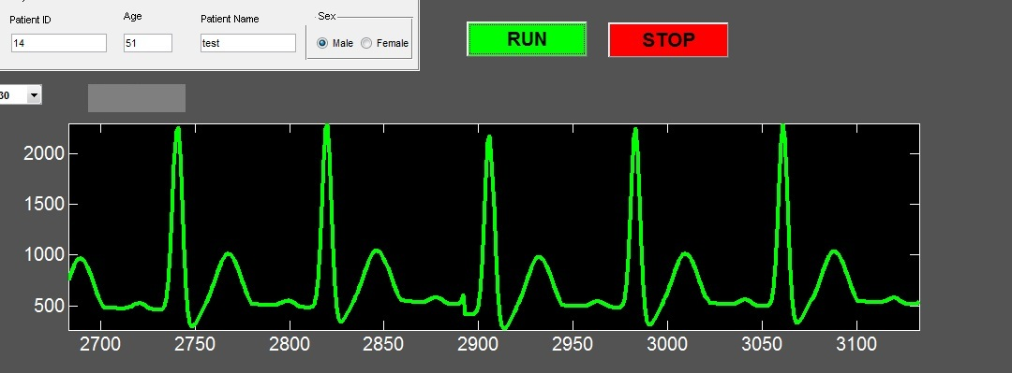

Develop an UI similar to the Matlab UI shown in the above Figure for android phones. Use the emulator to display the UI if you do not have Android smartphone. For graphing, use the graphView class provided in the blackboard. If you want to use the other third-part library instead of the graphView (we provide), it is no problem.

First, you generate a sample array of floats using the random library. Whenever the “Run button” is hit, the array is plotted in the canvass. On clicking the “Stop button”, drawing graph should be stopped and the view should be cleared. And, if you click the “Run button” again, drawing the graph should be restarted continuously (without clearing the previous graph). Also, the graph should be drawn and moved (updated without cleaning the whole graph) continuously before “Stop button” was clicked. In the other words, you should design and simulate the graph of the real heartbeat signal monitoring in hospital.

Deliverables:
- The source code of your app (acknowledge reused code – mark what is your own code).
- The comments on your source code are required.

Grading Rubric

Testing Environment for Grading
If possible, please follow the below environment setting to avoid you receive the wrong grade. Sometimes, your source code does not work correctly since your development environment is different to the below environment. At that time, we could not give the correct grade because it is not easy to find the reason why your application works incorrectly.
- Nexus 5
- Target API 21 or API 22

Achievable full credit - 100
Condition | Grade deductions
- App runs without being unresponsive  - Can fill patient data  - Graph updates continuously after one time clicking Run button  - Graph clears on hitting Stop button | 0
If app is unresponsive at any stage | 50
Graph not showing | 50
Cannot fill patient data | 30
Cannot hit run button multiple times | 30
Cannot hit stop button multiple times | 30
Graph in layout but no data | 40
Graph with data but cannot update | 25
No graph axis labels | 20
No follow submission method | 70

